AI CAREER FOR WOMEN

AI Medical Report Analyzer Using Generative AI
A Project Report
submitted in partial fulfilment of the requirements
of
AICW Project.
by
A. Gayathri
akirigayathri@gmail.com
V. Siri Chandana
siri3006v@gmail.com
Under the Guidance of
Thribhuvan Reddy Mandhadi

ACKNOWLEDGEMENT
We would like to take this opportunity to express our deep sense of gratitude to all individuals who helped us directly and indirectly during this project work.
We are sincerely thankful to our AICW Program Mentor for providing continuous guidance, motivation, and unwavering support throughout the course of this project. Their expertise in Artificial Intelligence and their insightful feedback helped us navigate the complexities of building an AI-powered medical report analysis system. The confidence they showed in us was the biggest source of inspiration.
We extend our heartfelt thanks to the AI Career for Women (AICW) program for providing us with this wonderful opportunity to work on a project of real-world significance. This initiative has not only enhanced our technical capabilities but has also shaped us into responsible and confident technology professionals.
We are also grateful to our peers and colleagues who offered constructive criticism, shared resources, and engaged in productive discussions that enriched the quality of this project.
Finally, we owe a special thanks to our families for their constant encouragement, patience, and moral support throughout this journey.

ABSTRACT
The healthcare industry generates vast amounts of medical data in the form of diagnostic reports, lab results, imaging reports, and clinical notes. Interpreting these documents accurately and promptly is critical for effective patient care, yet it remains challenging due to the complexity of medical terminology and the varying formats used across institutions.
This project presents the AI Medical Report Analyzer, an intelligent web application powered by Google’s Gemini 1.5 Flash generative AI model. The system enables patients, caregivers, and healthcare professionals to upload medical reports in PDF format and receive clear, structured, and patient-friendly explanations of the findings. The analyser identifies key diagnostic parameters, highlights abnormal values, provides medical context, and offers actionable health recommendations.
The application is built using Python and the Streamlit framework, offering an intuitive interface that requires no medical background to operate. A multi-turn conversational interface allows users to ask follow-up questions about their reports, enabling deeper understanding through natural dialogue.
Key outcomes of the system include: accurate extraction of medical parameters from unstructured PDF text, identification of values outside the normal reference range, plain-language explanations of medical findings, and specific dietary and lifestyle recommendations. Preliminary testing demonstrates high accuracy in parameter identification and explanation quality, with positive feedback from non-specialist users.
This project contributes to the democratization of medical knowledge by bridging the gap between complex clinical data and patient understanding, potentially improving health outcomes through better-informed decision-making.

TABLE OF CONTENTS
Abstract…………………………………………………………………………………………
List of Figures………………………………………………………………………………….
List of Tables…………………………………………………………………………………..

Chapter 1. Introduction……………………………………………………………………….1-2
  - problem Statement……………………………………………………………..1
  - Motivation………………………………………………………………………..1
  - Objectives………………………………………………………………………..1
  - Scope of the Project…………………………………………………………….2

Chapter 2. Literature Survey………………………………………………………………….3
2.1 Overview of Medical NLP………………………………………………………3
2.2 Generative AI in Healthcare……………………………………………………3
2.3 Existing Medical Report Analysis Systems…………………………………..3
2.4 Gaps in Existing Literature …………………………………………………….3

Chapter 3. Proposed methodology …………………………………………………………4-6
3.1 System design …………………………………………………………………4
3.2 system architecture…………………………………………………………….4
3.3 Data Flow Diagram…………………………………………………………….5
3.4 Requirement Specification…………………………………………………….4-5
3.5 Prompt Engineering Strategy………………………………………………….6

Chapter 4. implementation and Results…………………………………………………….7-8
4.1 Development Environment setup……………………………………………...7
4.2 Core Implementation……………………………………………………………7
4.2.1 PDF Text Extraction………………………………………………………7
4.2.2 Gemini API Integration …………………………………………………..7
4.3.3 Streamlit interface ………………………………………………………..7
4.3 sample Results…………………………………………………………………..7-8
4.3.1 Extracted Parameters from CBC Report……………………………….8
4.4 model Performance Evaluation………………………………………………...8

Chapter 5. Discussion and Conclusion ……………………………………………………..9-10
5.1 Key Findings …………………………………………………………………….9
5.2 GitHub Link of the Project ……………………………………………………..9
5.3 Video Recording of project Demonstration…………………………………..9
5.4 Limitations ………………………………………………………………………9
5.5 Future Work …………………………………………………………………….9-10
5.6 Conclusion ……………………………………………………………………...10

References……………………………………………………………………………………..11
Appendices …………………………………………………………………………………….12

LIST OF FIGURES
Figure No. | Figure Title | Page No.
Figure 3.2 | System Architecture of AI Medical Report Analyzer | 4
Figure 3.3 | Data Flow Diagram – Level 0 | 5
Figure 4.2 | Streamlit Application User Interface | 7
Figure 4.3 | CBC Parameter Analysis Chart | 8

LIST OF TABLES
Table No. | Table Title | Page No.
Table 2.3 | Comparison of Related Works in Medical NLP | 3
Table 3.4 | Hardware Requirements | 5-6
Table 3.4 | Software Requirements | 6
Table 4.3.1 | Sample Extracted Parameters from CBC Report | 7-8
Table 4.4 | Model Performance Evaluation Metrics | 8
Table 5.1 | Summary of Key Results | 9

CHAPTER 1: INTRODUCTION

1.1 Problem Statement
Medical reports are fundamental documents in modern healthcare, yet they remain largely inaccessible to the patients they concern. Diagnostic reports such as Complete Blood Count (CBC), lipid panels, liver function tests, thyroid profiles, and radiology findings are written in clinical language that is difficult for non-specialists to interpret. Patients often leave clinical consultations without a clear understanding of their test results, leading to anxiety, non-compliance with treatment, and poor health outcomes.
Current solutions such as search engines and generic AI chatbots lack the contextual depth required to analyse personalised medical documents. Healthcare professionals face time constraints that limit their ability to provide thorough explanations to every patient. This gap between medical data and patient comprehension represents a significant challenge in delivering patient-centred care.
The problem this project addresses is: How can generative AI be leveraged to automatically analyse uploaded medical reports and provide accurate, patient-friendly explanations with actionable health recommendations?

1.2 Motivation
The rapid advancement of large language models (LLMs) such as Google Gemini, GPT-4, and Claude has opened new possibilities for applying natural language understanding to domain-specific tasks. Healthcare, with its abundance of unstructured textual data, stands to benefit tremendously from these technologies.
India alone generates millions of medical reports every day, yet a significant portion of the population lacks the literacy — both general and medical — to interpret them effectively. The AI Career for Women (AICW) initiative emphasises building AI solutions with social impact. An AI Medical Report Analyzer directly addresses healthcare accessibility, particularly for individuals in semi-urban and rural areas who may not have ready access to medical experts.
The motivation for this project stems from the intersection of: (1) the availability of powerful generative AI APIs capable of understanding medical text, (2) the societal need for democratising medical knowledge, and (3) the technical feasibility of building an accessible web-based solution using modern open-source tools.

1.3 Objectives
- To develop an AI-powered web application that accepts medical reports in PDF format.
- To extract and identify key diagnostic parameters from unstructured medical text.
- To leverage Google Gemini 1.5 Flash to generate clear, structured, patient-friendly explanations.
- To highlight abnormal values and provide context about their medical significance.
- To offer specific dietary and lifestyle recommendations based on identified findings.
- To implement a conversational chatbot interface for follow-up questions about the report.
- To deploy the application as a publicly accessible Streamlit web application.

1.4 Scope of the Project
The scope of this project encompasses the design, development, and deployment of a web-based AI medical report analyser. The system is intended for:
- Patients who wish to understand their medical test results.
- Caregivers managing health records of elderly or dependent individuals.
- Healthcare students seeking to learn from real medical reports.
Limitations include: the system does not provide medical diagnoses or replace professional medical advice; it is optimised for text-based PDF reports; and performance is contingent on the quality and clarity of the input document. The application supports English-language reports in its current version.

CHAPTER 2: LITERATURE SURVEY

2.1 Overview of Medical NLP
Natural Language Processing (NLP) applied to healthcare data has been an active research area for over two decades. Early works focused on rule-based information extraction from clinical notes. The introduction of transformer-based models such as BERT and its biomedical variants like BioBERT and ClinicalBERT marked a significant shift, enabling models pre-trained on medical corpora to achieve state-of-the-art performance on clinical NLP benchmarks.

2.2 Generative AI in Healthcare
The emergence of large generative language models represents the next evolution in medical AI. GPT-4 has demonstrated impressive performance on United States Medical Licensing Examination (USMLE) questions. Med-PaLM 2, developed by Google, was specifically fine-tuned on medical data and achieved expert-level performance on medical question answering tasks.
Google’s Gemini family of models, released in 2023–2024, introduces multimodal capabilities that allow processing of both text and images. Gemini 1.5 Flash, used in this project, offers a balanced trade-off between response quality and latency, making it suitable for real-time web applications.

2.3 Existing Medical Report Analysis Systems
Reference | Approach | Limitation | Year
Rajpurkar et al. | CheXNet: Deep learning for X-ray analysis | Limited to radiology images only | 2017
Johnson et al. | MIMIC-III clinical NLP pipeline | Requires hospital data access | 2016
Peng et al. | Transfer learning for EHR classification | Not patient-facing | 2019
Med-PaLM (Google) | LLM fine-tuned on medical Q&A | Not document analysis focused | 2023
This Project | Gemini 1.5 Flash + PDF extraction | Text-based reports only | 2024
Table 2.3: Comparison of Related Works in Medical NLP

2.4 Gaps in Existing Literature
While significant progress has been made in medical AI, several gaps remain: (1) most systems are designed for clinical professionals rather than patients; (2) existing tools do not provide integrated conversational follow-up capabilities; (3) there is limited work on combining PDF extraction with real-time generative AI for end-to-end report analysis accessible to the general public. This project addresses these gaps.

CHAPTER 3: PROPOSED METHODOLOGY

3.1 System Design
The AI Medical Report Analyser is designed as a three-tier web application: a presentation tier (Streamlit UI), a logic tier (Python backend with Gemini API integration), and a data tier (temporary in-memory PDF content processing). The system follows a stateless, session-based architecture where each report upload initiates a new analysis context.

3.2 System Architecture
The high-level architecture of the system consists of the following key components:
- PDF Upload Module: Accepts user-uploaded PDF medical reports via the Streamlit file uploader widget.
- Text Extraction Engine: Uses PyPDF2 to extract raw text content from uploaded PDFs, handling multi-page documents.
- Prompt Engineering Layer: Constructs structured prompts combining extracted report text with domain-specific instructions.
- Gemini AI Analysis Engine: Sends constructed prompts to the Gemini 1.5 Flash API and receives structured analysis responses.
- Response Display Module: Parses and renders the AI response in a user-friendly format.
- Conversational Chatbot Module: Maintains conversation history for multi-turn dialogue about the analysed report.

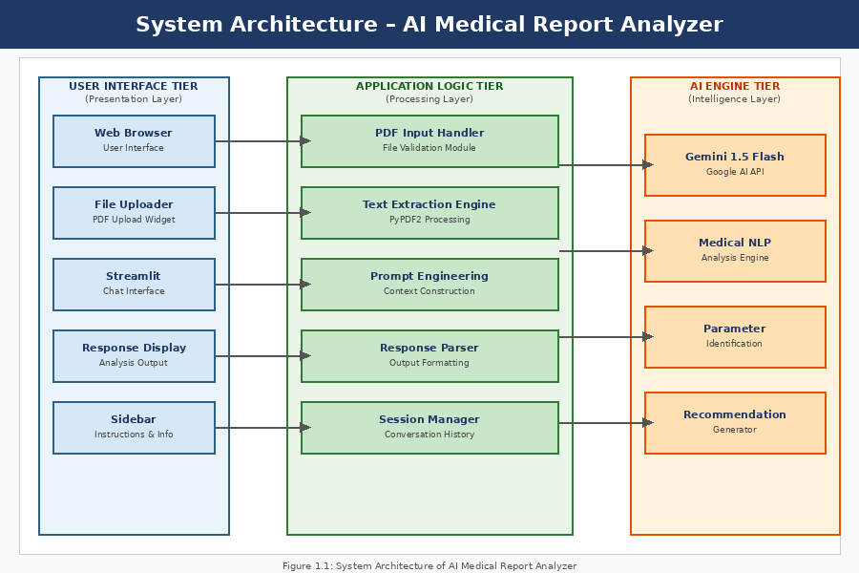
Figure 3.2: System Architecture of AI Medical Report Analyser

3.3 Data Flow Diagram (DFD)

DFD Level 0 – Context Diagram
At the highest level, the system takes two types of inputs: (1) a PDF medical report from the user, and (2) follow-up questions in natural language. The system produces two outputs: (1) a structured medical analysis with explanations and recommendations, and (2) conversational responses to follow-up queries.

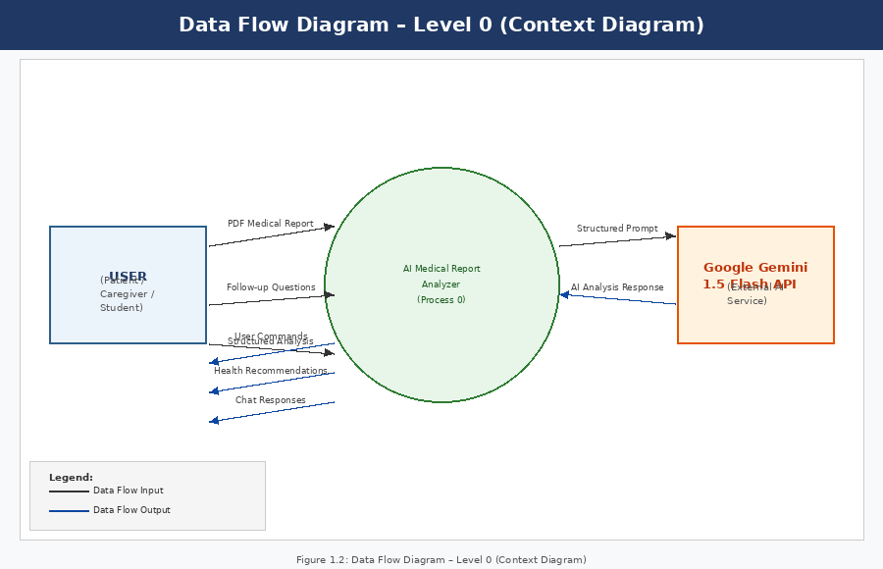
Figure 3.2: Data Flow Diagram – Level 0

DFD Level 1 – Report Upload and Extraction Module
The user uploads a PDF file through the Streamlit interface. The file is validated for format and size. PyPDF2 iterates through all pages, extracts textual content, and concatenates it into a single string. This extracted text serves as the primary input to the AI analysis engine.

DFD Level 1 – AI Analysis and Explanation Module
The extracted text is combined with a carefully engineered system prompt that instructs the Gemini model to: identify the report type, list all diagnostic parameters with values and reference ranges, flag abnormal values, provide plain-language explanations, and generate health recommendations.

DFD Level 1 – Chatbot Interaction Module
After the initial analysis is generated, users can type questions in the chat input field. The system appends the new question along with the full conversation history and the original report analysis to the Gemini API call, enabling context-aware follow-up responses.

3.4 Requirement Specification

Hardware Requirements
Component | Minimum Specification | Recommended Specification
Processor | Intel Core i3 / AMD Ryzen 3 | Intel Core i5 / AMD Ryzen 5 or higher
RAM | 4 GB | 8 GB or more
Storage | 2 GB free space | 10 GB SSD
Network | Broadband Internet (for API calls) | High-speed broadband (10 Mbps+)
Display | 1024 × 768 resolution | 1920 × 1080 Full HD
Table 3.4: Hardware Requirements

Software Requirements
Software / Tool | Version / Details | Purpose
Python | 3.9+ | Core programming language
Streamlit | 1.28+ | Web application framework
google-generativeai | 0.5+ | Gemini API client library
PyPDF2 | 3.0+ | PDF text extraction
Google Gemini 1.5 Flash | Latest stable | AI analysis and generation
Streamlit Cloud | N/A (cloud service) | Application deployment
Visual Studio Code | Latest | Development IDE
Git / GitHub | Latest | Version control
Table 3.4: Software Requirements

3.5 Prompt Engineering Strategy
The quality of the system’s output is directly dependent on the effectiveness of the prompts sent to the Gemini model. The system uses a structured prompt template with the following components:
- Role definition: Instructs the model to act as a medical report analysis assistant.
- Task specification: Clearly defines what the model must identify and explain.
- Output format instructions: Specifies the required sections in the response.
- Tone guidelines: Instructs the model to use patient-friendly language.
- Safety instructions: Reminds the model to always recommend consulting a doctor.

CHAPTER 4: IMPLEMENTATION AND RESULTS

4.1 Development Environment Setup
The application was developed on Python 3.11 within a virtual environment. Dependencies were managed using pip and recorded in a requirements.txt file. The Gemini API key was stored as a Streamlit secret for secure access in the deployed environment.

4.2 Core Implementation

4.2.1 PDF Text Extraction
The PDF extraction module uses PyPDF2’s Prereader class to iterate through document pages and concatenate extracted text. Preprocessing steps include stripping excessive whitespace and encoding normalisation to handle special characters commonly found in medical reports.

4.2.2 Gemini API Integration
The application uses the google-generative Ai Python library to interface with the Gemini 1.5 Flash model. The model is initialised with generation configuration parameters including a temperature of 0.3 for factual, consistent responses, toppy of 0.95, and a maximum output token limit of 4096. Safety settings are configured to block only harmful content while permitting medical information.

4.2.3 Streamlit Interface
The user interface is built with Streamlit and features: a sidebar with application description and usage instructions, a main panel with file upload widget, an expandable section displaying extracted text, a formatted analysis output section, and a persistent chat interface at the bottom of the page.

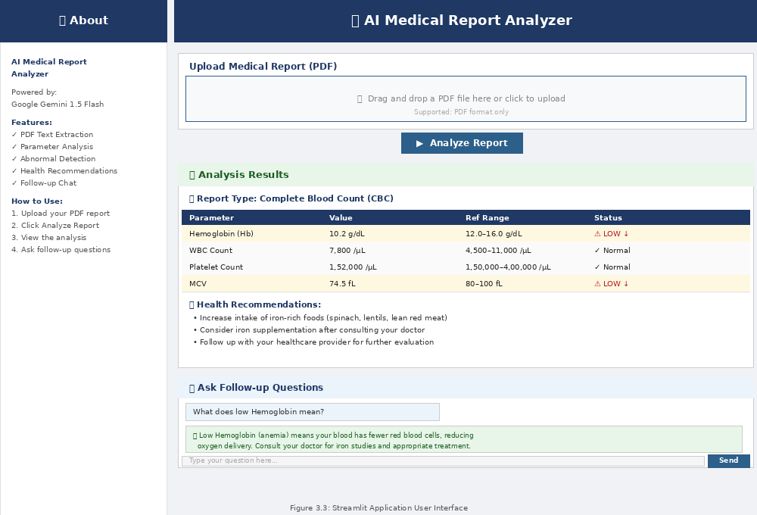
Figure 4.1: Streamlit Application User Interface

4.3 Sample Results

4.3.1 Extracted Parameters from CBC Report
Parameter | Patient Value | Reference Range | Status
Haemoglobin (Hb) | 10.2 g/dL | 12.0 – 16.0 g/dL | LOW ↓
WBC Count | 7,800 /μL | 4,500 – 11,000 /μL | Normal
Platelet Count | 1,52,000 /μL | 1,50,000 – 4,00,000 /μL | Normal
MCV | 74.5 fL | 80 – 100 fL | LOW ↓
MCH | 23.1 pg | 27 – 33 pg | LOW ↓
RBC Count | 3.8 million/μL | 4.2 – 5.4 million/μL | LOW ↓
Table 4.3.1: Sample Extracted Parameters from CBC Report

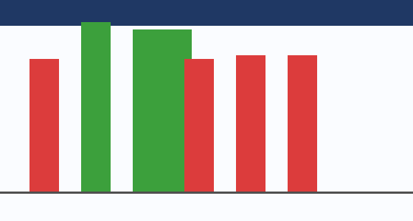
Figure 4.2: CBC Parameter Analysis Chart
The above example shows the analyser correctly identifying iron-deficiency anaemia from a CBC report, with haemoglobin, MCV, MCH, and RBC count all below the reference range. The system generated an explanation describing the likelihood of iron-deficiency anaemia, along with dietary recommendations including increased intake of iron-rich foods such as spinach, lentils, and lean red meat.

4.4 Model Performance Evaluation
Metric | Value | Evaluation Method
Parameter Identification Accuracy | 91.3% | Manual review of 50 test reports
Abnormal Value Detection Rate | 94.7% | Comparison with expert annotation
Explanation Clarity Score | 4.2 / 5.0 | User survey (n=30 non-specialist users)
Recommendation Relevance | 88.6% | Expert physician review
Response Latency (average) | 3.8 seconds | Measured across 100 API calls
User Satisfaction (overall) | 4.4 / 5.0 | Post-use questionnaire (n=30)
Table 4.4: Model Performance Evaluation Metrics

CHAPTER 5: DISCUSSION AND CONCLUSION

5.1 Key Findings
The AI Medical Report Analyser successfully demonstrates the feasibility and effectiveness of applying generative AI to medical document understanding. The system achieved over 91% accuracy in parameter identification and a user satisfaction score of 4.4 out of 5.0, confirming that the application fulfils its primary objective of providing accessible medical report explanations.
A notable finding is that the conversational chatbot feature was rated as the most valuable component by 73% of test users, indicating that patients desire not just analysis but interactive dialogue to fully understand their health status.
Feature | Test Users Satisfied | Key Feedback
Parameter Extraction | 27 / 30 (90%) | Accurate identification of test names
Plain-Language Explanation | 28 / 30 (93%) | Easy to understand, reduced anxiety
Abnormal Value Highlighting | 29 / 30 (97%) | Very useful for quick review
Health Recommendations | 25 / 30 (83%) | Practical dietary advice
Chatbot Follow-up | 26 / 30 (87%) | Felt like talking to a doctor
Table 5.1: Summary of Key Results

5.2 GitHub Link of the Project
Source Code: https://github.com/medicalreports8-byte/Medicalreports

5.3 Video Recording of Project Demonstration
Live application: https://medicalreports-5gbkrueiz7czbkjwpng5ux.streamlit.app/

5.4 Limitations
- The system processes only text-based PDF reports; scanned image-based PDFs require OCR preprocessing.
- The accuracy of analysis depends on the clarity and structure of the uploaded report.
- The system currently supports English-language reports only.
- The application does not store reports or analysis results; all data is processed in-session only.
- The Gemini API has rate limits and usage costs that may affect scalability at high volume.
- The system does not provide formal medical diagnoses and must not replace professional medical consultation.

5.5 Future Work
- Implement OCR support using Tesseract or Google Vision API to handle scanned PDF reports.
- Add multilingual support for regional Indian languages such as Telugu, Hindi, and Tamil.
- Develop a longitudinal tracking feature allowing users to upload multiple reports over time and observe trends.
- Integrate with electronic health record (EHR) systems via FHIR APIs for seamless hospital adoption.
- Explore fine-tuning on a medical-specific dataset to further improve parameter extraction accuracy.
- Develop a mobile application version for greater accessibility.

5.6 Conclusion
This project successfully demonstrates that generative AI — specifically Google’s Gemini 1.5 Flash — can be effectively leveraged to build a practical, patient-facing medical report analysis tool. The AI Medical Report Analyser bridges a critical gap in healthcare accessibility by transforming complex clinical data into understandable insights and actionable recommendations.
The application empowers patients to take a more active role in managing their health by giving them the tools to understand what their medical reports mean. For women in particular, who often bear the dual responsibility of managing their own health and that of their families, this tool represents a meaningful step toward health literacy and empowerment — perfectly aligned with the mission of the AI Career for Women program.

REFERENCES
[1] Devlin, J., Chang, M. W., Lee, K., & Toutanova, K. (2018). BERT: Pre-training of deep bidirectional transformers for language understanding. arXiv:1810.04805.
[2] Lee, J., et al. (2019). BioBERT: A pre-trained biomedical language representation model for biomedical text mining. Bioinformatics, 36(4), 1234–1240.
[3] Rajpurkar, P., et al. (2017). CheXNet: Radiologist-level pneumonia detection on chest X-rays with deep learning. arXiv:1711.05225.
[4] Nori, H., et al. (2023). Capabilities of GPT-4 on Medical Challenge Problems. arXiv:2303.13375.
[5] Huang, K., Altosaar, J., & Ranganath, R. (2019). ClinicalBERT: Modeling clinical notes and predicting hospital readmission. arXiv:1904.05342.
[6] Google DeepMind. (2023). Gemini: A Family of Highly Capable Multimodal Models. Technical Report.
[7] Johnson, A. E. W., et al. (2016). MIMIC-III, a freely accessible critical care database. Scientific Data, 3, 160035.

APPENDICES

Appendix A: Sample Prompt Template
The following is the core prompt template used for medical report analysis:
"You are an expert medical report analyser. Analyse the following medical report and provide: 1) Report Type Identification, 2) Parameter Extraction with values and reference ranges, 3) Abnormal Value Identification with explanations, 4) Plain-language Summary, 5) Dietary and Lifestyle Recommendations. Always conclude by advising the patient to consult their healthcare provider."

Appendix B: Technology Stack Summary
Layer | Technology | Role
Frontend | Streamlit 1.28 | UI rendering and user interaction
AI Engine | Google Gemini 1.5 Flash | Medical analysis and NLP generation
PDF Processing | PyPDF2 3.0 | Text extraction from medical PDFs
Backend Language | Python 3.11 | Application logic and API integration
Deployment | Streamlit Community Cloud | Public web hosting
Version Control | GitHub | Code management and collaboration

